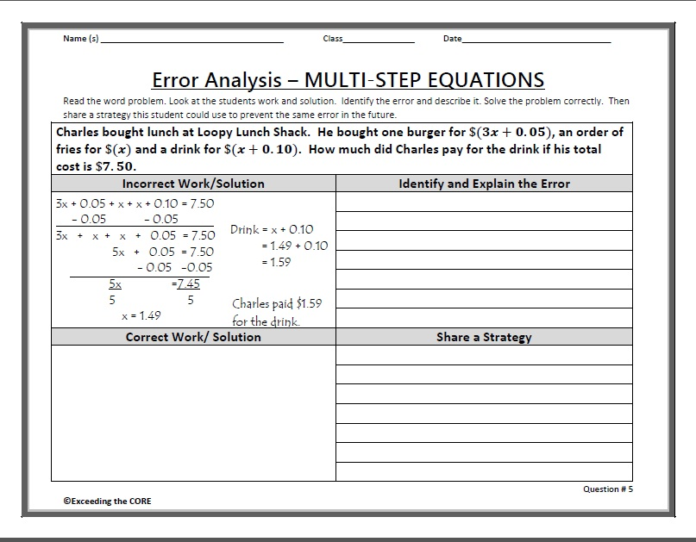
Name: ____________________________________ Class: ____________________
Error Analysis Multi-Step Equations Interactive Rubric
Points | Component | Points Earned/ Comments
4 points | Identify and Explain the Error  - Student states the error in the word problem and where it occurred.  - Student explains why the error is incorrect and why the student may have made the mistake.
4 points | Correct Work/Solution  - Student writes a “let statement” to identify the variable.  - Student writes the correct equation for the problem.  - Student solves their equation correctly using properties of equality.  - Student writes one sentence about their solution in the context of the problem.
2 points | Share a Strategy  - Student creates their own strategy that will help the student avoid making this mistake in the future.

