8th Grade Winter Break Packet
- (8.EE. 1) Which shows (11⁶)² in exponential form?
  - 22⁶
  - 11¹²
  - 11⁸
  - 11⁴
- (8.EE.1) Which shows 9⁻³ in standard form?
  - 729
  - 27
  - $\frac{1}{27}$
  - $\frac{1}{729}$
- (8.EE.1) Which shows (2²)⁻² in standard form?
  - 0
  - $\frac{1}{16}$
  - $\frac{1}{8}$
  - 1
- (8.EE.1) Which shows 5⁴ in standard form?
  - 20
  - 625
  - 1,024
  - 3,125
- (8.EE.1) What is the value of this expression 4² $∙$ 4⁻³?
  - $\frac{1}{4096}$
  - $\frac{1}{1024}$
  - $\frac{1}{4}$
  - 4
- (8.EE.1) Which expression equals x¹²?
  - x² $∙$ x⁶
  - x⁴ $∙$ x³
  - x¹¹ $∙$ x
  - x $∙$ x¹²
- (8.EE.1) What is the value $\frac{4^{8}}{4^{6}}$ ?
  - 8
  - 16
  - 32
  - 64
- (8.EE.1) What is the value of the expression: $\frac{3^{3} ∙ 3^{-4} ∙ 3^{6}}{3^{8} ∙ 3^{-2} ∙ 3^{-5}}$
  - 5
  - 81
  - 243
  - 729

- (8.EE.1) Which is an equivalent expression for (3²)⁻⁵?
  - -3⁷
  - -3¹⁰
  - $\frac{1}{3^{7}}$
  - $\frac{1}{3^{10}}$
- (8.EE.1) Which expression(s) is equal to 2⁻¹²?
Expression 1: (2⁻² $∙$ 2⁻⁸)⁻² Expression 2: ${\left( \frac{2^{-5}}{2^{-2}∙{ 2}^{-1}} \right)}^{6}$
  - Expression 1
  - Expression 2
  - Both expression 1 and 2
  - Neither expression 1 nor 2
- (8.EE.1) Which expression is equivalent to $\frac{6^{-4}}{6^{-2}}$ ?
  - 6⁻⁶
  - 6⁻²
  - 6²
  - 6⁸
- (8.EE.1) Which shows $\frac{6^{-1}}{6^{-4}}$ in exponential form?
  - 6⁻⁵
  - 6⁻³
  - 6¹
  - 6³
- (8.EE.1) Which expression is equal to (7⁵)⁻⁴
  - 7⁻²⁰
  - 7⁻⁹
  - 7
  - 7²⁰
- (8.EE.2) One side of a triangular garden is $\sqrt{15}$ feet long. Which is the best estimate of the length of the side?
  - 3.17 feet
  - 3.18 feet
  - 3.87 feet
  - 3.92 feet
- (8.EE.2) The diagonal of a rectangle measures $\sqrt{5}$ meters long. Which is the best estimate of the length of the diagonal?
  - 1.9 meters
  - 2.2 meters
  - 2.3 meters
  - 2.5 meters

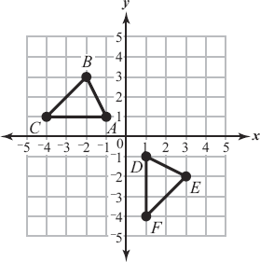
- (8.G.2) Which sequence of transformations can map Triangle ABC onto Triangle DEF?

  - A counterclockwise rotation by 90° about the origin
followed by a reflection across the y-axis
  - A counterclockwise rotation by 90° about the origin
followed by a translation down by 2 units
  - A counterclockwise rotation by 180° about the origin
followed by a reflection across the y-axis
  - A counterclockwise rotation by 180° about the origin
followed by a translation down by 2 units
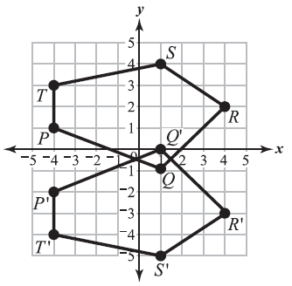
- (8.G.2) Which statement is correct about the two figures PQRST and P’Q’R’S’T’?

  - They are congruent because figure P’Q’R’S’T’ is
obtained by reflecting figure PQRST across the line y = -1.
  - They are congruent because figure P’Q’R’S’T’ is
obtained by reflecting figure PQRST across the line x = 1.
  - They are congruent because figure P’Q’R’S’T’ is
obtained by reflecting figure PQRST across the x-axis and
then translating it down by 1 unit.
  - They are congruent because figure P’Q’R’S’T’ is
obtained by reflecting figure PQRST across the x-axis
and then translating it down by 2 units.
- (8.G.2)Which sequence of transformations will map the polygon ABCD below onto the polygon A'B'C'D'?
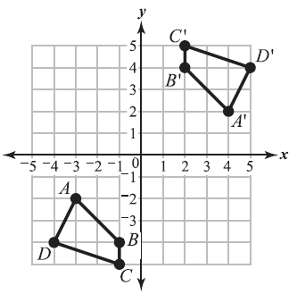
  - A counterclockwise rotation by 90$°$ about the origin
followed by a translation of 1 unit to the right
  - A counterclockwise rotation by 90° about the origin
followed by a translation of 4 units to the right
  - A counterclockwise rotation by 180° about the origin
followed by a translation of 1 unit to the right
  - A counterclockwise rotation by 180° about the origin
followed by a translation of 4 units to the right

- (8.G.3) A blueprint of a sailboat has a sail in the shape of a right triangle, RST. On the blueprint the vertices are R(-4, 6), S(-4, 2), and T(1, 2). What are the coordinates of the sail after a reflection over the x-axis?
  - R’(-4,6), S’(-4,2), T’(1,2)
  - R’(-4,-6), S’(-4,-2), T’(1,-2)
  - R’(6,-4), S’(2,-4), T’(2,1)
  - R’(-6,-4), S’(-2,-4), T’(2,1)
- (8.G.3) In Trapezoid PQRS, the coordinates of vertex R are (5, -5). What are the coordinates of the image of point R after the trapezoid is translated 8 units to the left?
  - (13,-5)
  - (-3,-5)
  - (5,3)
  - (-5,-5)

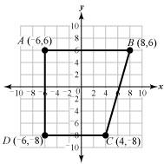
- (8.G.3) The figure ABCD below is dilated by a scale factor of $\frac{1}{2}$ to obtain the figure A'B'C'D' . Which statement best describes the sides and angles of figure A'B'C'D' ?

  - $\overline{A'B'}$ is parallel to $\overline{C'D'}$ and m∠D'A'B' = m∠DAB.
  - $\overline{A'B'}$ is parallel to $\overline{B'C'}$ and m∠D'A'B' = m∠DAB.
  - $\overline{A'B'}$ is parallel to $\overline{C'D'}$ and m∠D'A'B' = m∠ABC.
  - $\overline{A'B'}$ is parallel to $\overline{B'C'}$ and m∠D'A'B' = m∠ABC.

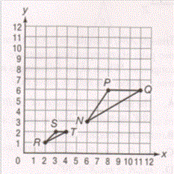
- (8.G.3) Triangle RST is the result of a dilation of triangle NPQ with the center of dilation at the origin and a scale factor of $\frac{1}{3}$

  - ∠N is congruent to ∠R.
  - ∠N is congruent to ∠S.
  - ∠P is congruent to ∠R.
  - ∠P is congruent to ∠T.

- (8.G.3) A point has the coordinates (110, 225). If the point is reflected across the line y = 215, what are the coordinates of the reflected point?
  - (110, 205)
  - (110, 235)
  - (110, 440)
  - (320, 225)
- (8.G.3) The image of point A after a dilation of 3 is (6, 15). What was the original location of point A?
  - (2, 5)
  - (3, 12)
  - (9, 18)
  - (18, 45)
- (8.G.4) What kind of transformation is a dilation?
  - A slide of a figure
  - A turn of a figure around a point
  - A stretching or shrinking of a figure
  - A flip of a figure over a line
- (8.NS.2) Which is closest to the value of $5\sqrt{15}$?
  - 19.5
  - 21.0
  - 8.8
  - 4.5
- (8.NS.2) Which is closest to the value of $\sqrt{90}- \frac{4}{11}$?
  - 7.8
  - 8.9
  - 9.1
  - 9.5
- (8.NS.2) Which is closest to the value of $\frac{\sqrt{19}}{\sqrt{5}}$ ?
  - 2.0
  - 3.8
  - 4.0
  - 9.5
- (8.NS.2) Which is approximately equal to $\sqrt{3}$ ?
  - $\frac{1}{3}$
  - 1.732050808…
  - 3.0
  - 9.732050808
- (8.NS.1) Which fraction is equivalent to 0.35?
  - $\frac{1}{5}$
  - $\frac{7}{20}$
  - $\frac{11}{20}$
  - $\frac{3}{5}$
- (8.NS.1) Which number below is not an irrational number?
  - $\sqrt{46}$
  - $\sqrt{47}$
  - $\sqrt{48}$
  - $\sqrt{49}$
- (8.NS.1) Which is the decimal expansion of $\sqrt{\frac{3}{11}}$ ?
  - $0.\overline{34}$
  - 0.3434
  - $0.\overline{27}$
  - 0.02727
- (8.G.1) Triangle ABC is rotated 90º clockwise to create Triangle EDC.
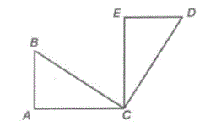
Which angle is congruent to angle B?
  - ∠BCE
  - ∠ECD
  - ∠E
  - ∠D

- (8.G.1) What set of coordinates will provide the vertices for the translation of triangle XYZ two units to the left?
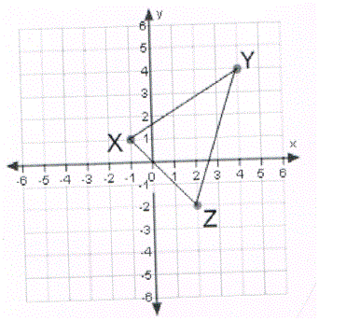
  - X’(1, 1), Y’(6, 4), Z’(4, -2)
  - X’(-1, 3), Y’(4, 6), Z’(2, 0)
  - X’(-3, 1), Y’(2, 4), Z’(0, -2)
  - X’(-3, 1), Y’(1, 4), Z’(-2, 0)

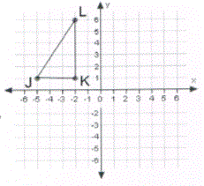
- (8.G.1) What set of coordinates will provide the vertices for a 90° clockwise rotation of triangle JKL about point K?

  - J’ (-2, 5) K’ (-2, 1), L’(4, 1)
  - J’ (-2, 4) K’ (-2, 1), L’(3, 1)
  - J’ (-2, 5) K’ (-2, 1), L’(3, 1)
  - J’ (-1, 4) K’ (-2, 1), L’(3, 1)

- (8.G.1) The measure of angle LMN is the same as the measure of angle L’M’N’. Use the two figures below, LMNO and L’M’N’O’ to justify why this is correct.
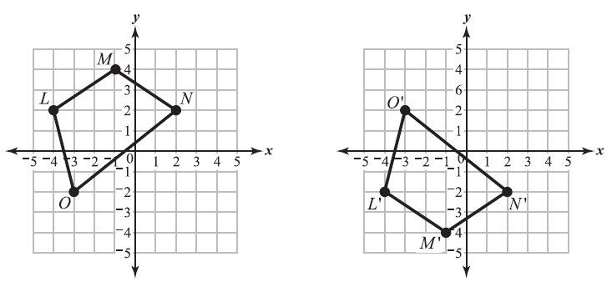
  - Figure LMNO is rotated 90° counterclockwise about the origin and then reflected across the x-axis to obtain figure L'M'N'O'.
  - Figure LMNO is reflected across the x-axis and then rotated 90° counterclockwise about the origin to obtain figure L'M'N'O'.
  - Figure LMNO is rotated 180° counterclockwise about the origin and then reflected across the y-axis to obtain figure L'M'N'O'.
  - Figure LMNO is reflected across the y-axis and then rotated 180° counterclockwise about the origin to obtain figure L'M'N'O'.
- (8.G.1) Triangle ABC is reflected over the x-axis to form triangle A'B'C'. What are the coordinates of vertex C'?
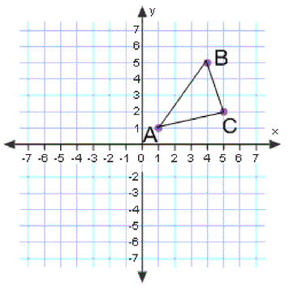
  - (-2, 5)
  - (-5, 2)
  - (-5, -2)
  - (5, -2)

- (8.EE.1) Strep throat is caused by Streptococcus bacteria. The amount of bacteria multiplies at a rate of 10¹³ per 10² hours.
Part A
What is the average growth of bacteria per hour? Show your work.

Part B
What is the total amount of bacteria present after 10³ hours? Show your work.

- (8.G.2) Part A: Figure ABCD is transformed to figure A’B’C’D’ by first reflecting ABCD across the y-axis, and then rotating the resulting figure counterclockwise about the origin by 180 °. Draw the transformed figure A’B’C’D’ on the grid shown below.
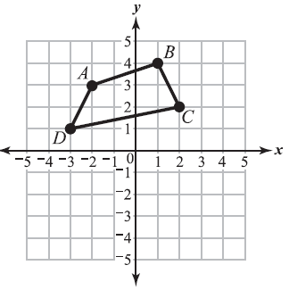
Part B
Figure A'B'C'D' is dilated by a scale factor of 3. Explain why the resulting figure will be or will not be congruent to ABCD.

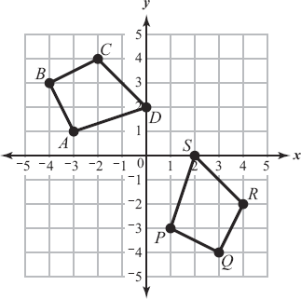

- (8.G.2) The figures to the right, ABCD and PQRS, are congruent figures.

Part A: Name a sequence of transformations that changes figure ABCD to figure PQRS

Part B: A student plots four points K (0, –3), L (–2, –4), M(–3, –2), and N (–1, 0)
on the grid. Is the figure KLMN congruent to the figure PQRS? Explain your answer.

